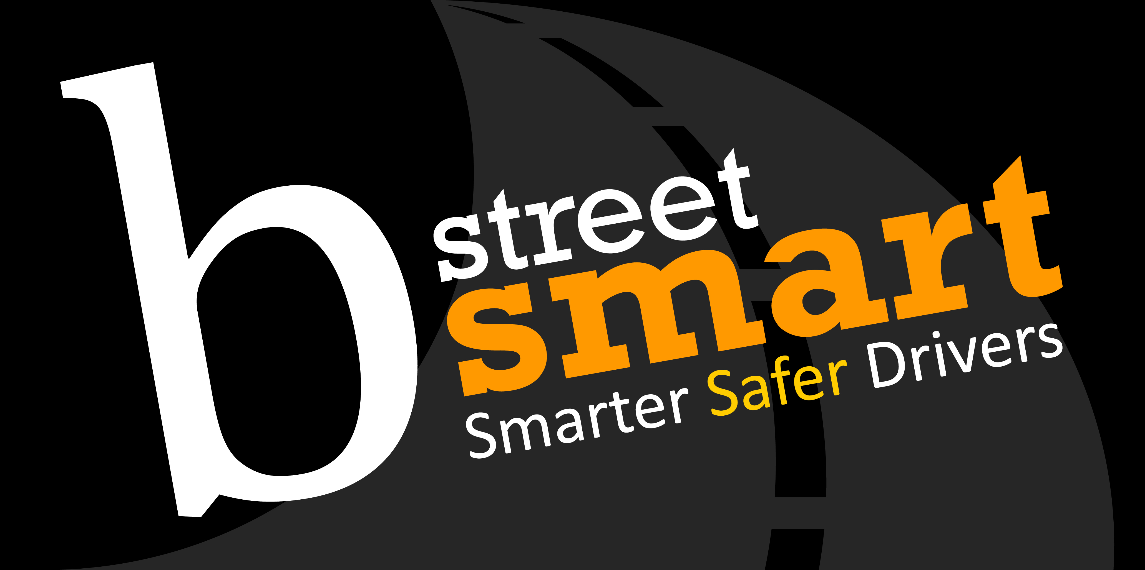
bstreetsmart 2024 Interactive Display Information
Student Numbers to date:
Tuesday 21 August – students
Wednesday 22 August – students
Thursday 23 August –

Total at present:
students from schools

Program:
2024 program is attached.

Parking:
Parking is in the P1 car park. The cost is fully subsidised by bstreetsmart.
Parking tickets must be handed in to the staff at the External Cloakroom first thing in the morning you will then get a subsidized ticket in return. Those in the crash scenario see me in the Green Room.
When at the External Cloakroom you will be given a wristband for identification purposes.

Please ensure your display is set up prior to students arriving from 9am.

Bump in times:
For Interactive displays with cars as part of their display, bump in must be done during the following times:
- Cars bump in for Concourse (through the main doors via Olympic Boulevard)
  - Monday 1400 – 1500
  - Tuesday 0630 – 0800

- General bump in (it is via the loading dock off Edwin Flack Avenue)
  - Monday 1200 – 1600
  - Tuesday 0630 – 0800

Your allocated areas will be on the provided map.

Bump out:
Thursday needs to occur after the students have all left, after 2pm. This will be strictly adhered to particularly for any cars that need to be driven around the concourse. Bump out must be completely finished on the Thursday.

Pre-delivery items:
If you have any boxes to be delivered to Qudos Bank Arena prior to the event, please arrange for them to be delivered as close to Monday 21 August. Please clearly mark them as “for bstreetsmart” and attention them to Mr Dan Hogan, Qudos Bank Arena, enter via loading dock, 19 Edwin Flack Drive, Sydney Olympic Park NSW 2127.

Teachers Packs:
All displays are encouraged to put together teacher’s packs for the teachers to take back to school and continue the road safety message education to the students. As there is no teacher’s lounge this year they will need to be available at your stand.
Total number of schools currently booked in over the 3 days 194.

Handouts:
Please be cognisant of what your organisation is giving as handouts to the students.
There cannot be any stickers (as per Qudos Bank Arena instructions) as they end up stuck on walls and mirrors. Balloons turn into water bombs and CD’s turn into Frisbees etc.

Counsellors:
Generous support from the WMH Social Work Department the plan is to have 4 on per day. T-shirts purchased for any unfortunate “protein spills”

VIP’s:
Should you have anyone to invite please send as soon as possible: chapin@bstreetsmart.org.
Interactive display requirements:
If your display requires power, you will need to bring along your own extension cord & power boards. All cords must be taped to the floor BUT you need to get special terrazzo tape supplied by Qudos Bank Arena. We will purchase rolls of tape for you to use.
If using Wi-Fi there will be a charge, amount unknown at this stage.

Compulsory Online Inductions
Any person entering or leaving (bumping in/bumping out) will need to complete the Qudos Bank Arena on-line induction prior to arriving onsite. When it asks for company details please select bstreetsmart. The induction typically takes 10-15mins. Please note, if crew are in the Crash Scenario they do not need to complete the online training.

1. See link below and click on REGISTER:

www.inductee.com.au/qudosbankarena

2. Click on REGISTER
3. CHOOSE the below
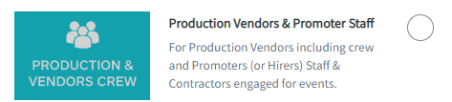

4. Fill in details under “Register New Account”
5. On the User Registration page, add the Company name (bstreetsmart) and job title (Interactive Display).
6. You will then be given a username and password to continue on to the training module.

Insurance:
Reminder to send your most updated Public Liability Insurance to Chapin as soon as possible.

Volunteers:
Many volunteers are needed to ensure the event is run smoothly on the days. If your organisation can assist us with volunteers (not the ones working on your displays), please let Chapin Ayres know: chapin@bstreetsmart.org

Food:
Food is available for all volunteers and participating organisations free of charge in the Q Bar at Qudos Bank Arena. We ask that you do not have lunch while the students are out looking at the Interactive Displays so eat before 1120 and after 1240.

Website:
If any organisation has any promotional material/facts sheets that they would like put on the website, please send them to Rachel rachel.watkins@health.nsw.gov.au

Updates:
- The Governor of NSW, The Honourable Margaret Beazley will be presenting the Welcome on Wednesday 23 August and watching the event
- There will be live streaming available to all schools in Australia on Thursday.

PR is being organised by Western Sydney LHD:
- The Channel 9 Today Show will be doing their live weather crosses from bstreetsmart on Wednesday 23 August. We may need your help with the weather crosses! Possible ABC filming as well.
.
THANK YOU ONCE AGAIN FOR YOUR INVALUABLE SUPPORT OF BSTREETSMART.

If you have any further questions, please feel free to contact us:

Rachel Watkins  8890 4716  0401 537 751  rachel.watkins@health.nsw.gov.au | Julie Seggie  8890 7058  0406 205 873  Julie.seggie@health.nsw.gov.au | Chapin Ayres  8890 7458  0400 818 756  chapin@bstreetsmart.org

