**EDUCATIONAL RESOURCE 2 – bstreetsmart Road Safety Program**

**The Facts**

Drivers who have just started driving on their provisional licence are the most likely to be involved in crashes. The following graph shows the number of drivers involved in crashes (Y axis) by the number of months they’ve held their licence (by different driver types) (X axis).

**NEW DRIVERS INVOLVED IN CRASHES**

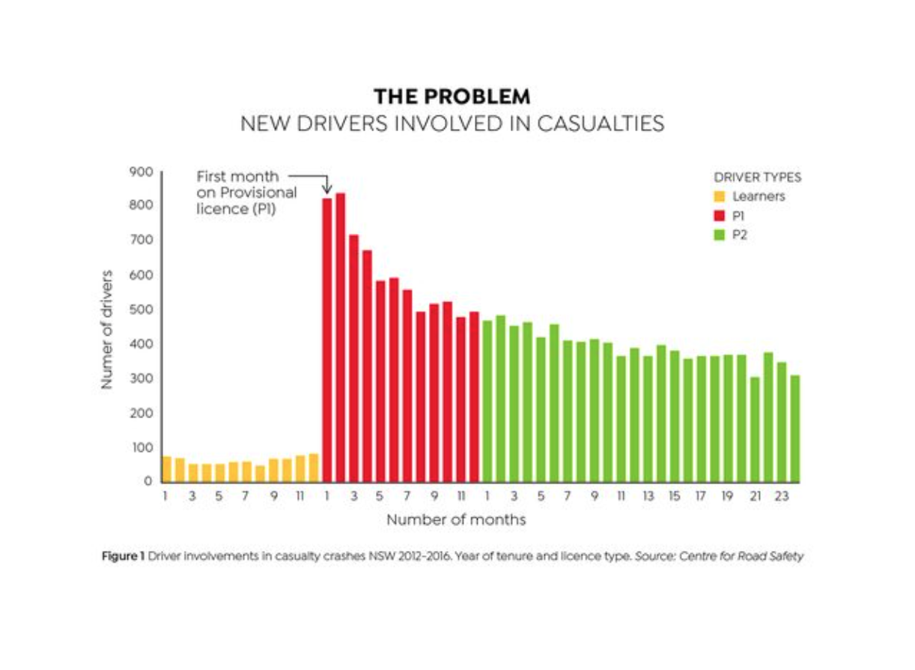

**Answer the following (individual activity)**

* What are some surprising findings in the above graph?
* Why do you think the rate of crashes is so low for learner drivers?
* Why do you think the rate of crashes goes up so quickly for provisional drivers?

**Debate (2 x teams of 3-4 people)**

The government should increase the number of hours that learner drivers hold a Learner’s Permit and not allow people to drive on a Provisional Licence until they are at least 20 years old.

**Design (individual activity)**

In an aim to decrease the number of crashes by drivers who have just got their Provisional licence, create a road safety awareness poster (A3 size) that targets this demographic. Think about the following:

* How will your poster appeal to this target audience?
* What visual elements will you use?
* What heading will likely catch their attention?
* Will you focus on one particular aspect of driver safety (such as driver distraction, speeding, fatigue or other)?
* What is your call to action? What do you want the target audience to do after seeing/reading your poster?